CHAPTER – 5
SYSTEM TESTING
5.1 System Testing
System testing is a phase of software testing where the complete and integrated software application is evaluated to verify that it meets all specified functional and non-functional requirements. In StreamHub, system testing validates the seamless interaction between the React frontend, Spring Boot backend, MySQL database, Redis cache, and FFmpeg media processing pipeline.
5.1.1 Output Testing
Output testing focuses on verifying whether the system produces the correct, expected, and formatted outputs upon receiving valid inputs. It ensures that media streams, user interfaces, notifications, and generated data reports comply with user expectations.
Home Feed
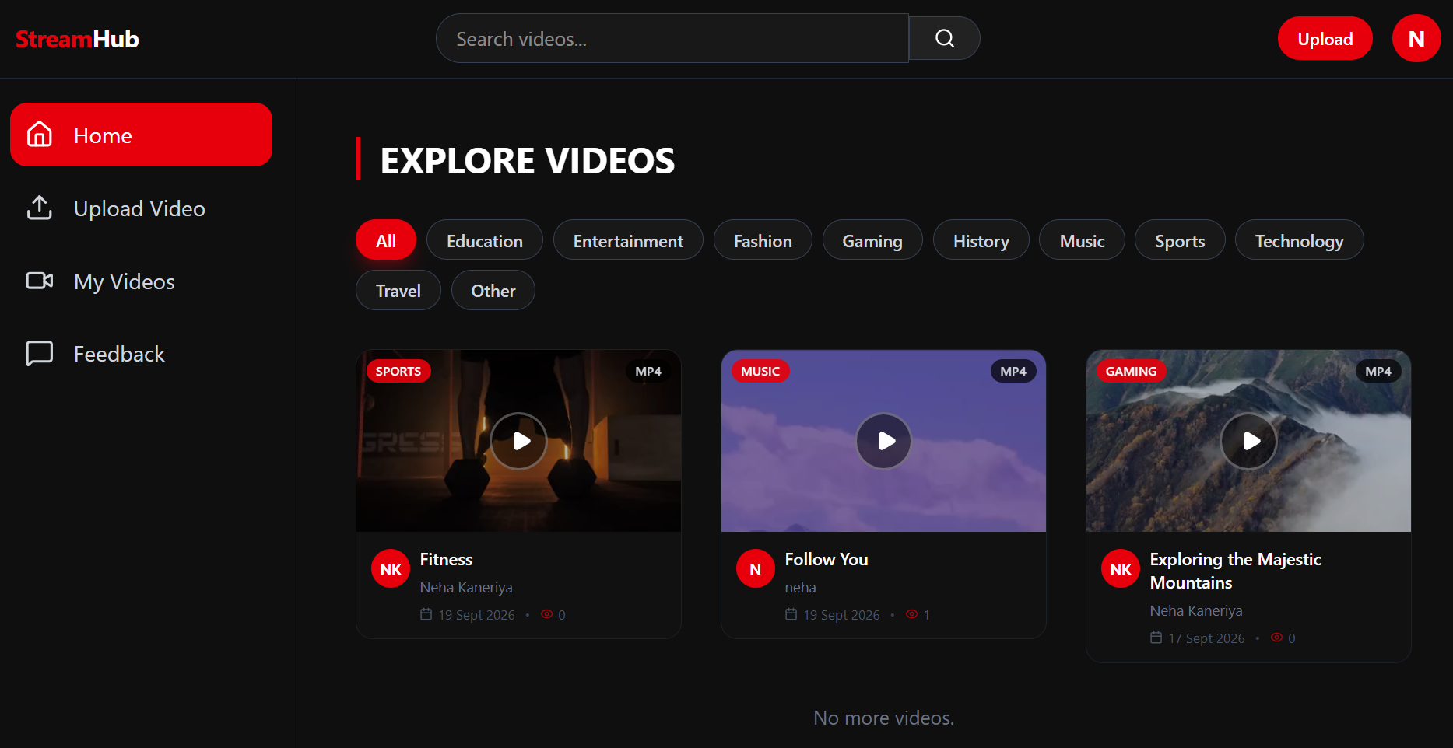
Video Playback + Quality
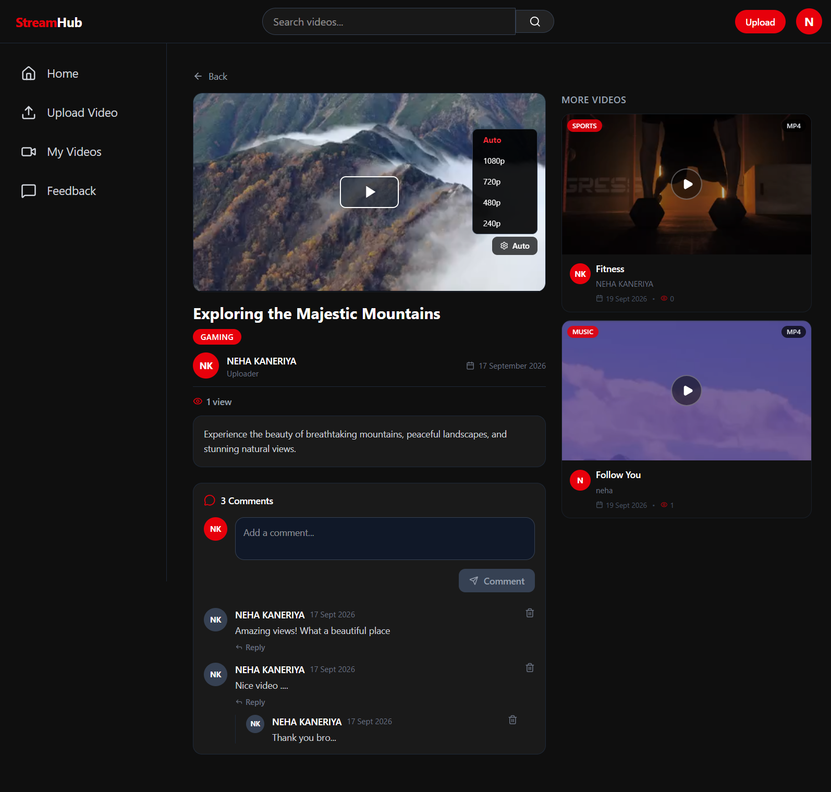
Upload Success
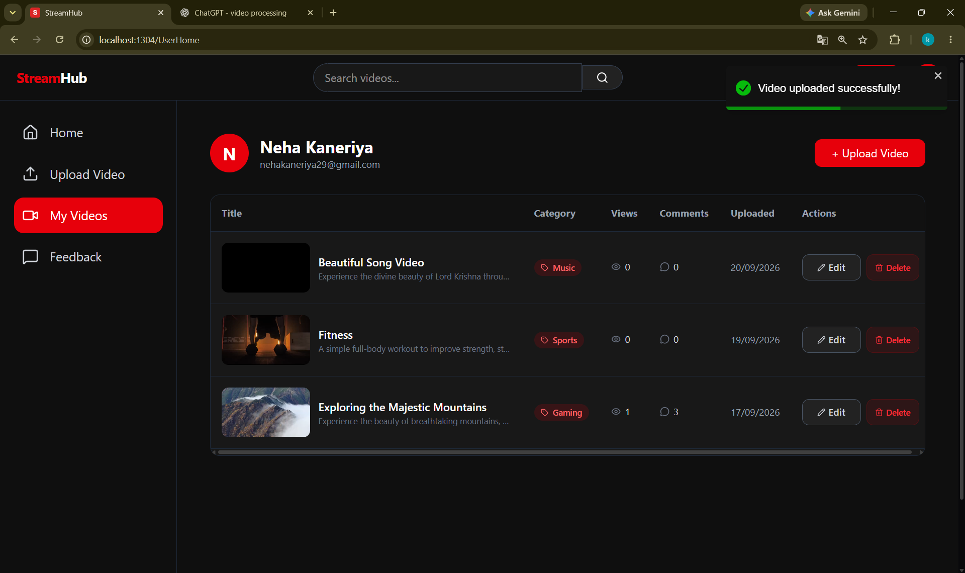
Email Verification Success
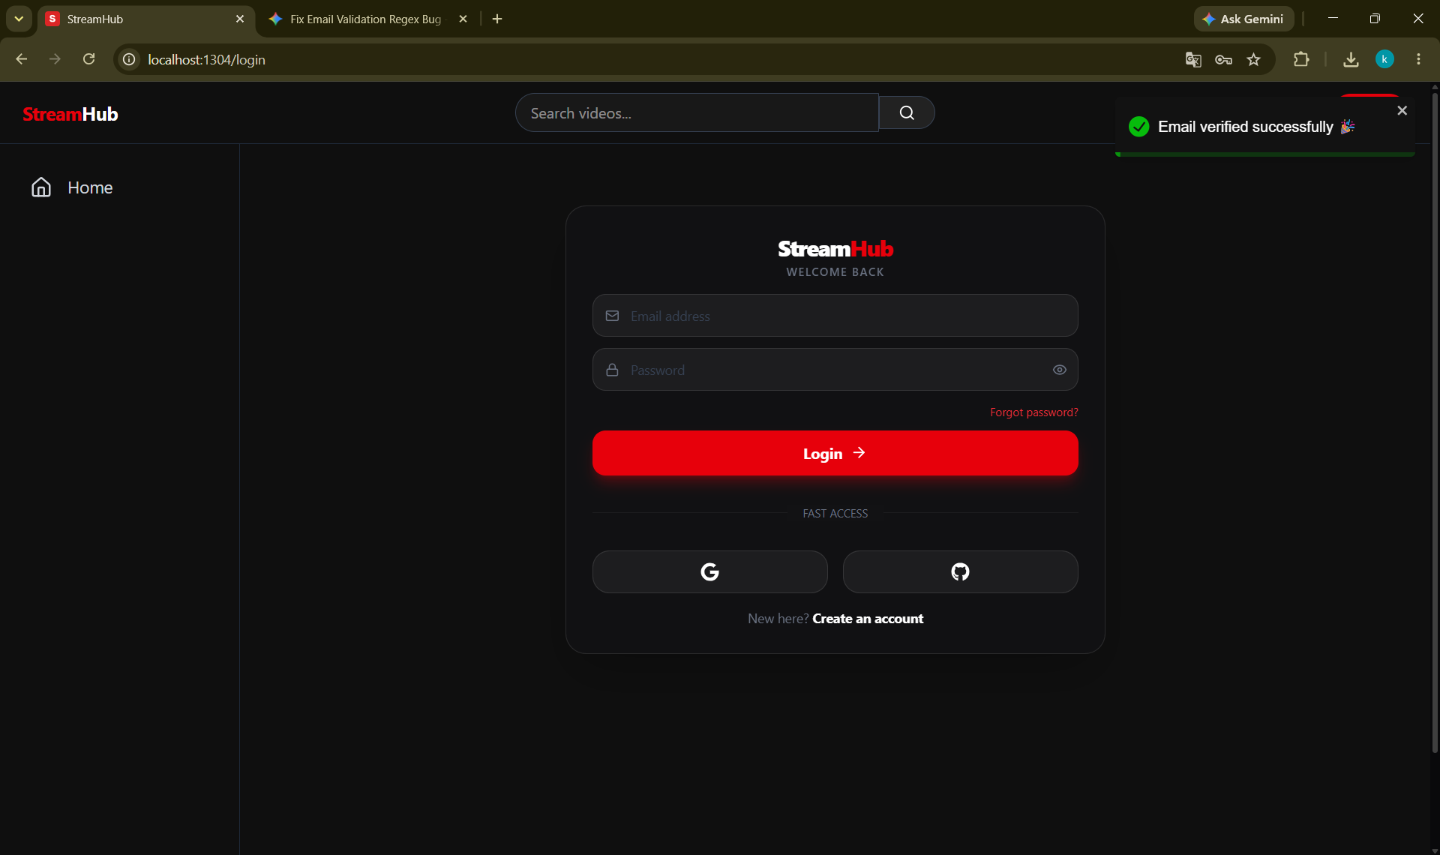
Login Success
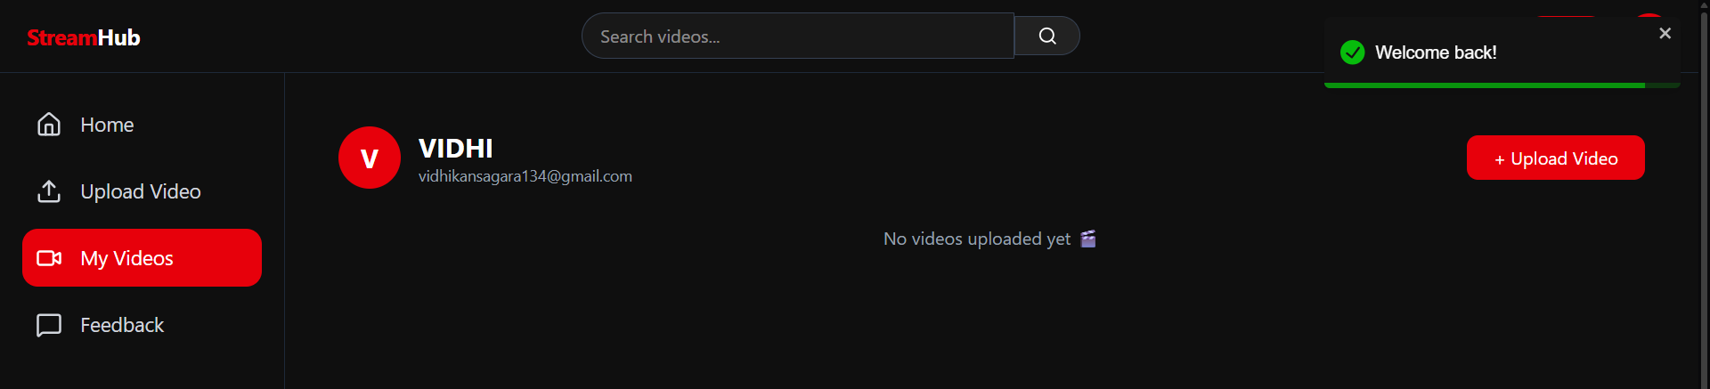
Search Result
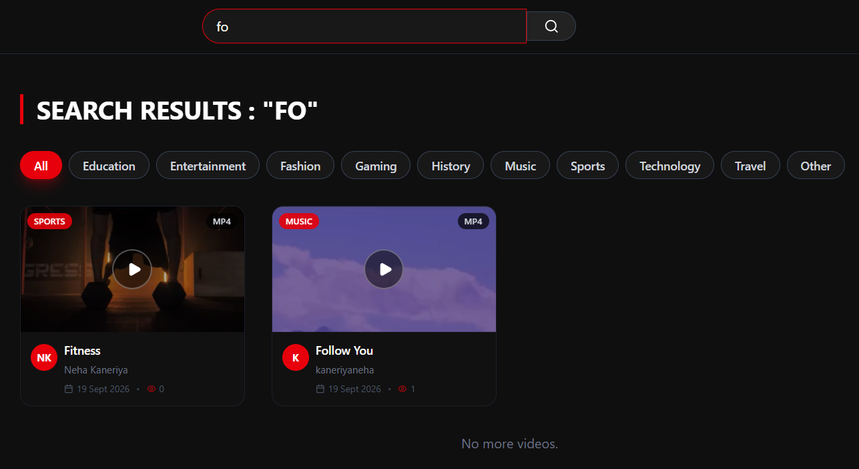
5.1.2 Validation and Verification Testing
Validation and verification testing ensures that the system satisfies both business rules and technical specifications:
Empty registration
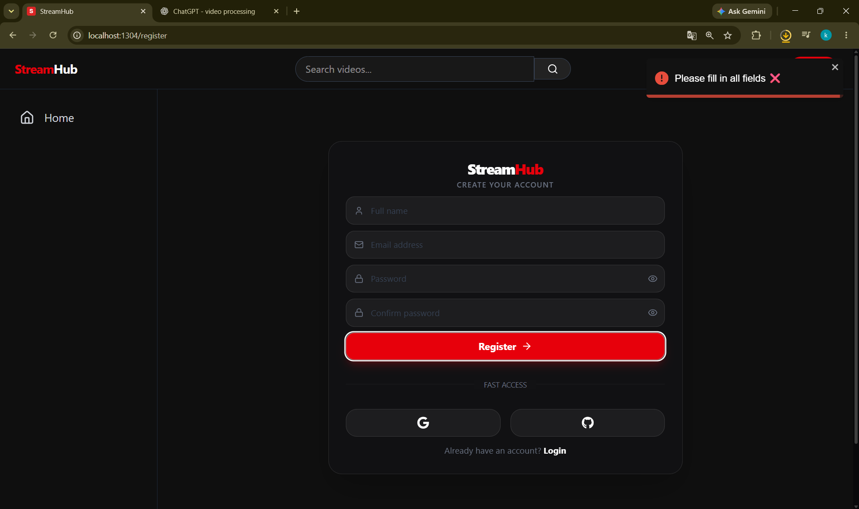
Password validation
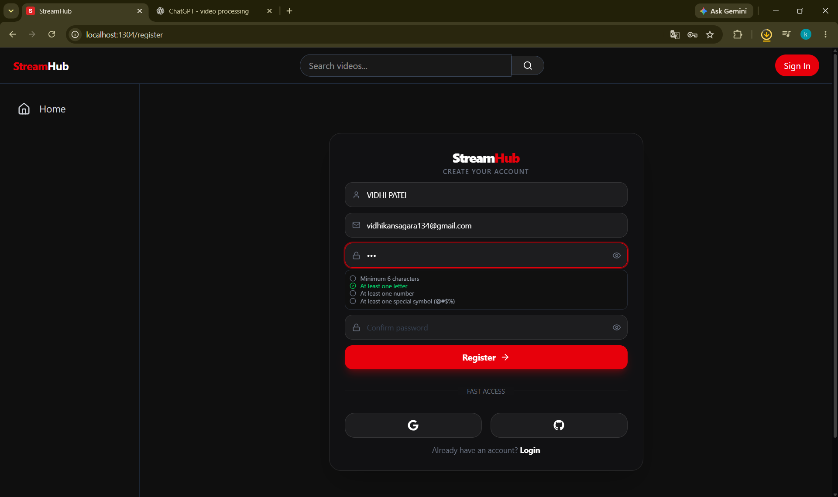
Password mismatch
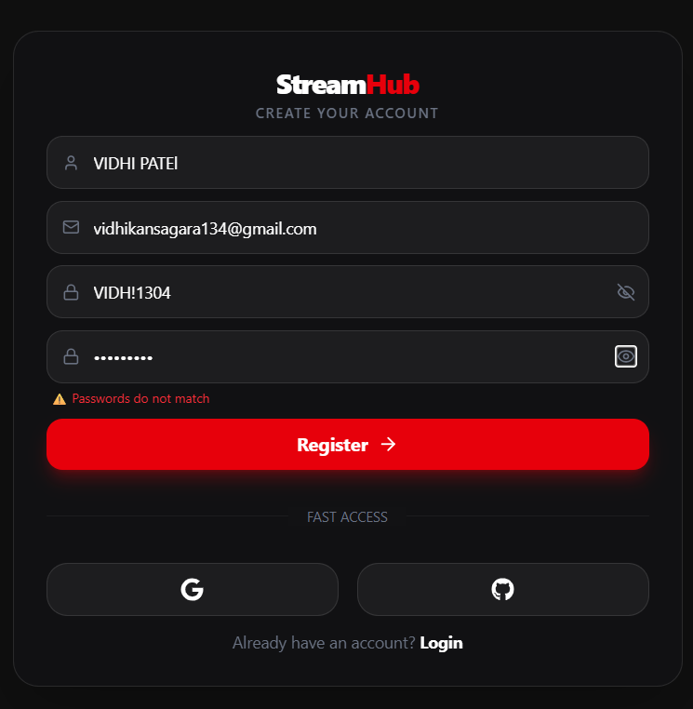
Existing email
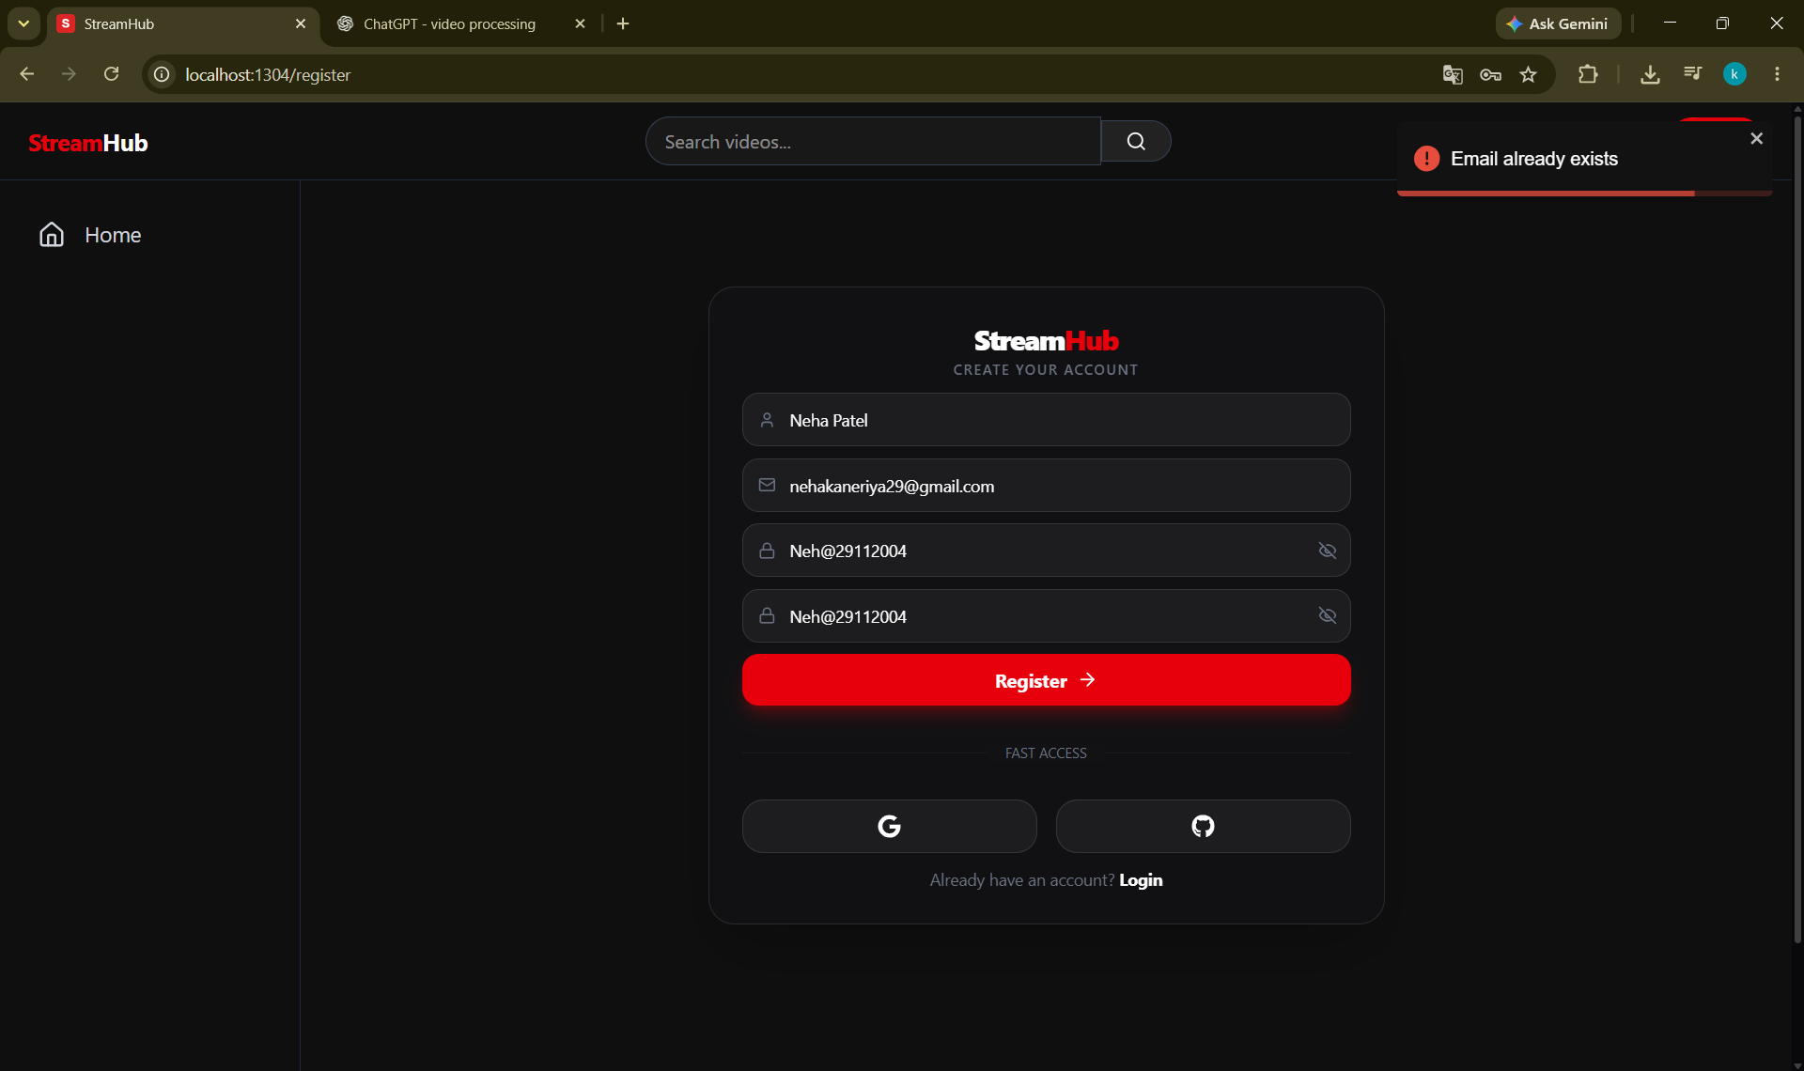
Empty OTP
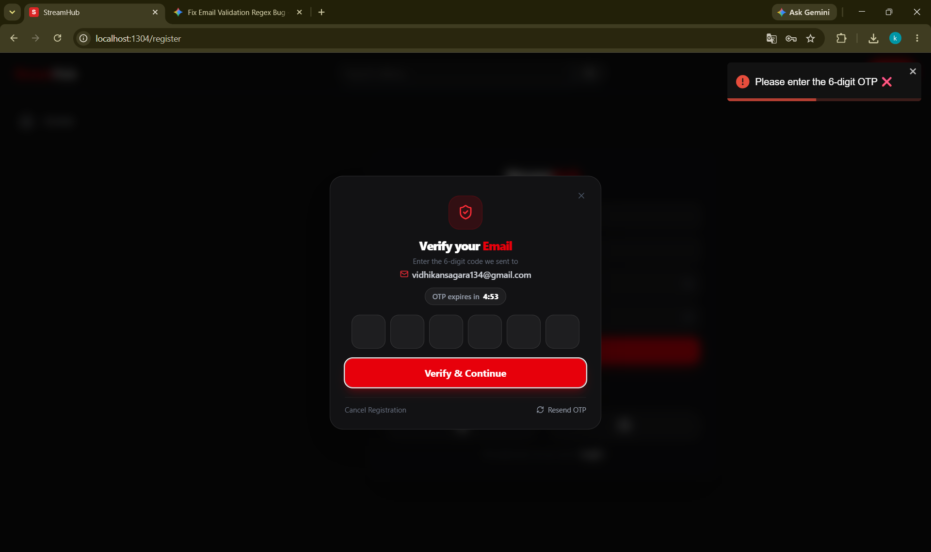
Wrong OTP
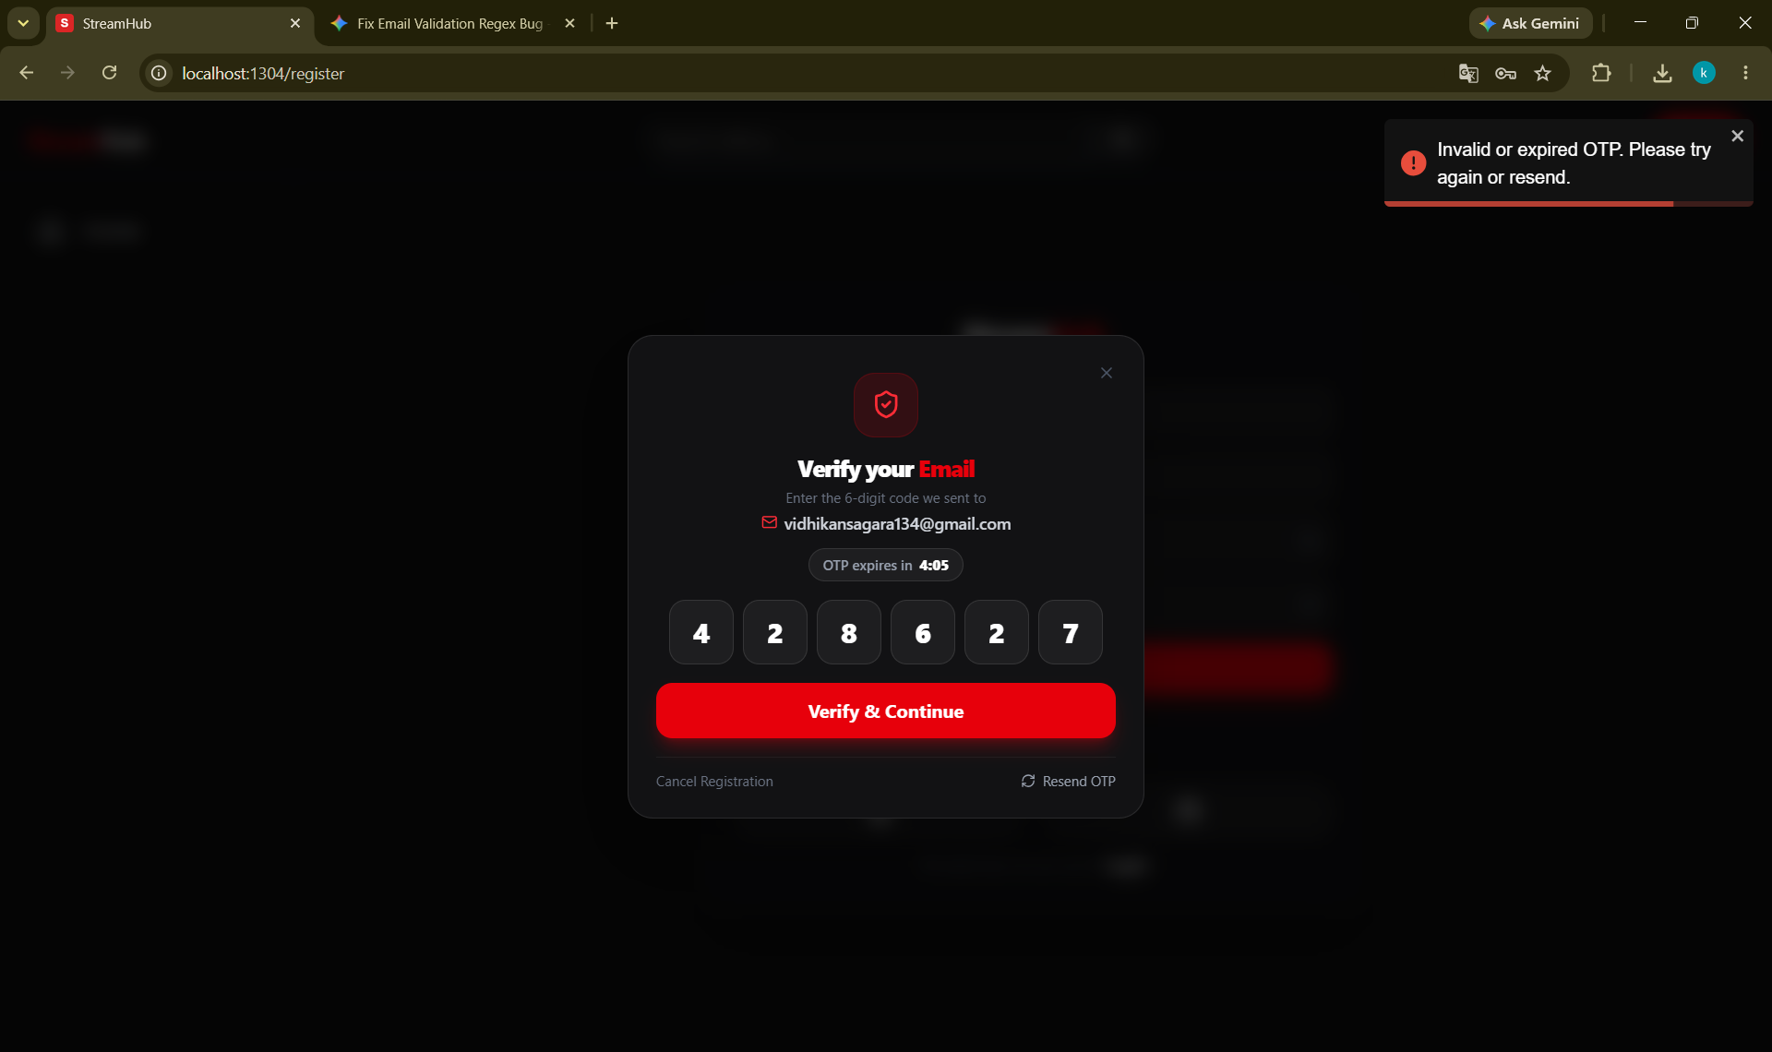
Registration cancelled
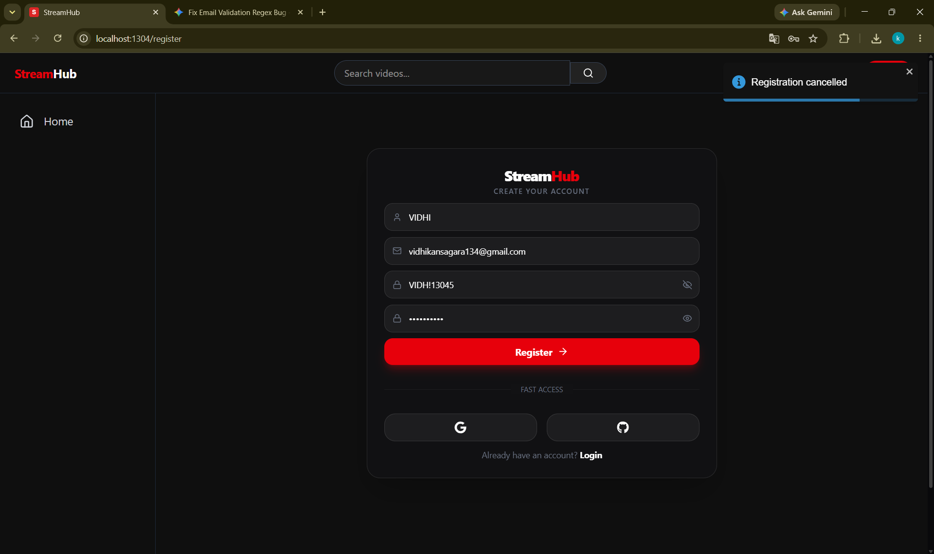
File Too Large
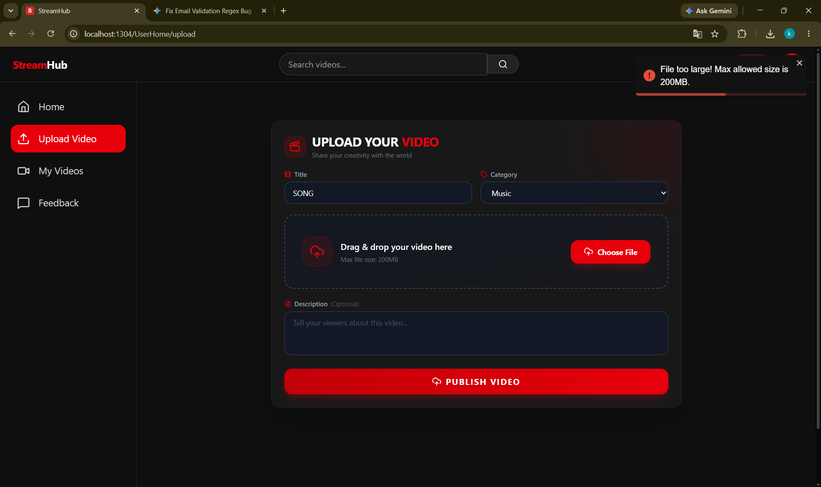
Comment Hide
